66th ANNUAL GENERAL BODY MEETING

NOVEMBER 07, 2015

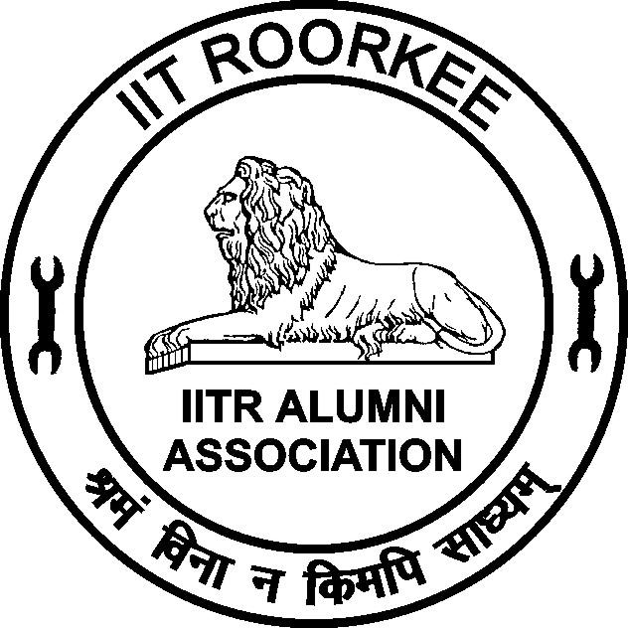

IITR ALUMNI ASSOCIATION
INDIAN INSTITUTE OF TECHNOLOGY ROORKEE
(Formerly University of Roorkee)
ROORKEE – 247 667

EXECUTIVE COMMITTEE 2015 – 2016
Prof. Prem Krishna
President
Prof. V. K. Gupta
Vice President
Dr. Achal Kumar Mittal
Honorary Secretary
Dr. R. D. Garg
Joint Secretary
Er. Dinesh Pawar
Treasurer
Prof. Sandeep Singh
Dean, Alumni Affairs & International Relations
Dr. Pradeep Kumar
Immediate Past Secretary
Elected Members

Dr. A. K. Gupta | Er. Mayank Kumar Tilak |  | Er. Pradeep Kumar Bansal
Ar. B. D. Mittal | Er. Nand Kishore Sharma |  | Dr. Rajnish Garg
Dr. Bhavana Sindhu | Er. Narendra Singh |  | Dr. Satyendra Mittal
Dr. Dinesh Kumar Garg | Er. Naresh Chandra Garg |  | Er. Sudhir Kumar Mittal
Er. H. K. Verma | Prof. P.P. Agarwal |  | Er. (Mrs.) Surjeet Sharma
Co-opted Members

Prof. A. K. Mathur |  | Prof. H. Sinvhal

Annexure

Agenda for 66th Annual General Body Meeting of IITR Alumni Association

- Kulgeet
- Welcome address by Secretary
- Obituaries
- Welcome Speech - by Vice President

  - Confirmation of minutes of the 65th AGBM held on November 05, 2014.
  - Presidential Address by Prof. Prem Krishna, President.
  - Felicitation of Silver Jubilee Alumni (1990 Batch, B.Arch. 1991 batch)
  - Address by the Director, IIT Roorkee.
  - To consider Annual Report for the period from November 01, 2014 to October 31, 2015.
  - To consider the Audited Accounts for the period from April 1, 2014 to March 31, 2015.
  - To appoint the Auditor for the financial year 2015 – 2016.
  - To consider the Provisional Budget for the year 2016 – 2017.
  - Any other item with the permission of the Chair

- Vote of Thanks
- National Anthem

  - Confirmation of the minutes of the 65th Annual General Body Meeting (AGBM) of the IIT Roorkee Alumni Association (IITRAA) held on November 05, 2014 at 4:30 PM in the O.P. Jain Auditorium of Civil Engineering Department of IIT Roorkee.

Please See Annexure -1

66.2 Presidential Address by Prof. Prem Krishna, President, IITR Alumni Association

Distinguished Guests; Dear Alumni, particularly the Silver Jubilee alumni, and, their families; Ladies and Gentleman:
I have great pleasure in welcoming you all to this, the 66th Annual General Meeting of the IIT Roorkee Alumni Association. I particularly wish to felicitate our Silver Jubilee Alumni of the 1990 batch, who left the portals of this great institution 25 years back. This was then the University of Roorkee, and as is well known got converted to an IIT in 2001. In fact this is its fourth avtaar in its long history since 1847 – the longest in engineering education in the Country. The important thing of which the Roorkee alumni can be proud, is that a tradition of excellence has been maintained, in whatever may have been the name or system under which the institution functioned. There have been changes all along but the most staggering is that on January 1848 there were 06 students, and, today this number is close to ten thousand!
The alumni have served the cause of National development admirably while also making their presence felt internationally. There is a large number, whose names one can reel out, of those of our alumni who reached the top positions in whatever vocation they got associated with. While some decades ago – there was a limited spectrum of opportunities for technical graduates – mostly in the public sector, today there is a much wider horizon created by the growth of the public sector and the industry following the opening up of the economy in the 1990s.The Silver Jubilee batch, which has grown with this change, and whom we are greeting today, has experienced this change directly.
The IITR Alumni Association has strength of about thirty thousand members spread across the globe. This is a reservoir of highly competent technical hands with a great potential – a “brain deposit” to use PM Modi’s terminology – National as well as International. The young alumni who inherit this wonderful band of Roorkee alumni year after year, have every reason to be proud of it. However, in order that the alumni as individuals or groups can tap the potential better, it is imperative that there is good connectivity. In this day and age of a strong e- media, this is not a problem, provided that a good database of contact information is available. Considerable effort has been made in this direction and there is good progress so far – though there is still some more remains to be done. A professional outfit has been given the contract to improve the contact database, and improve and maintain the IITRAA website. We are also working towards introducing an ‘on–line’ election process for electing the Executive Council 2015-16, which will enable much wider participation compared to earlier years.
Furthermore the issue of a bimonthly e-Newsletter since July 2014 has helped in bringing out news of our alumni. We are hoping also to bring out ‘memorabilia’- volumes called ‘SMRITIKA’ for the degree recipients of 2016. In all these new initiatives the support and cooperation from the Director, Professor Pradipta Banerjee and the Dean AAIR, Prof. Sandip Singh. has been invaluable.
Before I end, I wish to congratulate the Silver Jubilee alumni and earnestly hope that they will carry fond memories of this re-union, and, return to the campus for their, Coral, Ruby, Golden, and, Diamond Jubilees. I thank all of you who have come to attend this Annual General Body Meeting, and have given me a patient hearing.
Prem Krishna
President,
IITR Alumni Association (2015 – 16)

66.3 Felicitation of Silver Jubilee Alumni (1990 Batch, B.Arch. 1991 batch)

66.4 Address by Prof. Pradipta Banerji, Director, IIT Roorkee, Roorkee.

  - To consider the Annual Report for the period November 01, 2014 to October 31, 2015, by the Honorary Secretary

Annual Report of the IITR Alumni Association

It is a great pleasure for me to present the Annual Report of the IITR Alumni Association for the period of November 01, 2014 to October 31, 2015. This report presents various activities undertaken by the Association during given time frame.

Membership

The membership of the Alumni Association is increasing steadily. At present, we have 30351 members as against 28330 members during the last year i.e. as on October 31, 2015. We have enrolled these members in the period since 1941. Looking into the present trend, it is likely to touch the magic number 50000 in next 15 years. If you remember, during your days of studies the number of students admitted was only 400-500, which are now a days about 1500 (which is approximately 3 to 4 Times).

Finance and Accounts

The audited accounts are printed on the following pages. As per the directions of the previous General Body of the Association, M/s Awasthi Prakash & Associates Chartered Accountant, Civil Lines, Roorkee have duly audited the accounts.

Jubilee Alumni Meet - 2014

The 2014 Jubilee Functions for the Alumni included customary Silver (25 years), Golden (50 Years) and Diamond (60 years) Jubilees, besides the two new additions, the Coral (35 years) and Ruby (40 years) introduced this time.
Silver Jubilee Alumni Meet, Ruby Jubilee Alumni Meet, Diamond & Golden Jubilee Alumni Meet – 2014 and Coral Jubilee Meet 2014 were celebrated with great enthusiasm on 05th & 06th November, 2014 , 17th & 18th November 2014, 24th & 25th November, 2014 and January 24th & 25th, 2015 respectively. There were 13 Diamond Jubilee Alumni (1954 batch), 83 Golden Jubilee Alumni (1964 batch), 20 Ruby Jubilee Alumni (1974), 120 Silver Jubilee Alumni (1989 batch) and 45 Coral Jubilee Alumni (1979) who attended the meet, many with their families. Some of the alumni had come for the first time after graduating from the erstwhile University of Roorkee.

All the Jubilee Alumni along with their families had separately met their respective batch mates with great zeal and nostalgia. They enjoyed games on Lal Bahadur Shastri Stadium with great gusto.

The Jubilee Alumni visited Anushruti (formerly Roorkee School for the Deaf) and many of them did noble thing of donations for the school. A large number of student volunteers participated in Jubilee function. Visiting alumni appreciated their enthusiasm and participation.

Annual General Body Meeting

The 65th Annual General Body Meeting of the Association was held in the evening of 05th November, 2014 in O.P. Jain Auditorium and was attended by over 200 members. The President of the Association welcomed the members of the association and the Jubilee Alumni who had graced the function. The minutes of the AGBM are as given in Annexure-1.

During the AGBM the Alumni of 1989 and 1990 (B. Arch) batches were felicitated for completing Silver Jubilee of their graduation.

Programme for Accompanying Spouses

An interesting session for all the accompanying spouses and children was organized in the Khosla International House (earlier Afro-Asian Hostel). In this session, an informal cultural function was arranged, where the spouses narrated interesting stories regarding their husbands and their emotional involvement with Roorkee. Accompanying children cherished this occasion with great enthusiasm.

Anushruti Programme

All the Jubilee Alumni visited Anushruti (formerly Roorkee School for the Deaf) and many of them did the noble thing of donations for the school.

Website

The Alumni Association has been able to establish its own independent website. The website is www.iitraa.in. This website is being maintained and updated from this year by a professional outfit called Alma Connect Solutions Pvt. Ltd.

E-newsletter

IITR Alumni Association has taken the initiative to bring out a bi-monthly e-newsletter. This e-newsletter is being sent to those members whose email addresses are available with us. It is also available on our website www.iitraa.in.

Acknowledgements

I am extremely grateful to Prof. Prem Krishna, President, Prof. Pradipta Banerji Director IITR and the Working President, for their guidance, support and encouragement received by me during the period.

I am thankful from the bottom of my heart to all the members of the Executive Committee and fellow Alumni from the Institute and all the local chapters who have helped me in the activities of the Alumni Association.

(Achal Mittal)
Honorary Secretary

  - To consider the Audited Accounts for the period from April 1, 2014 to March 31, 2015.
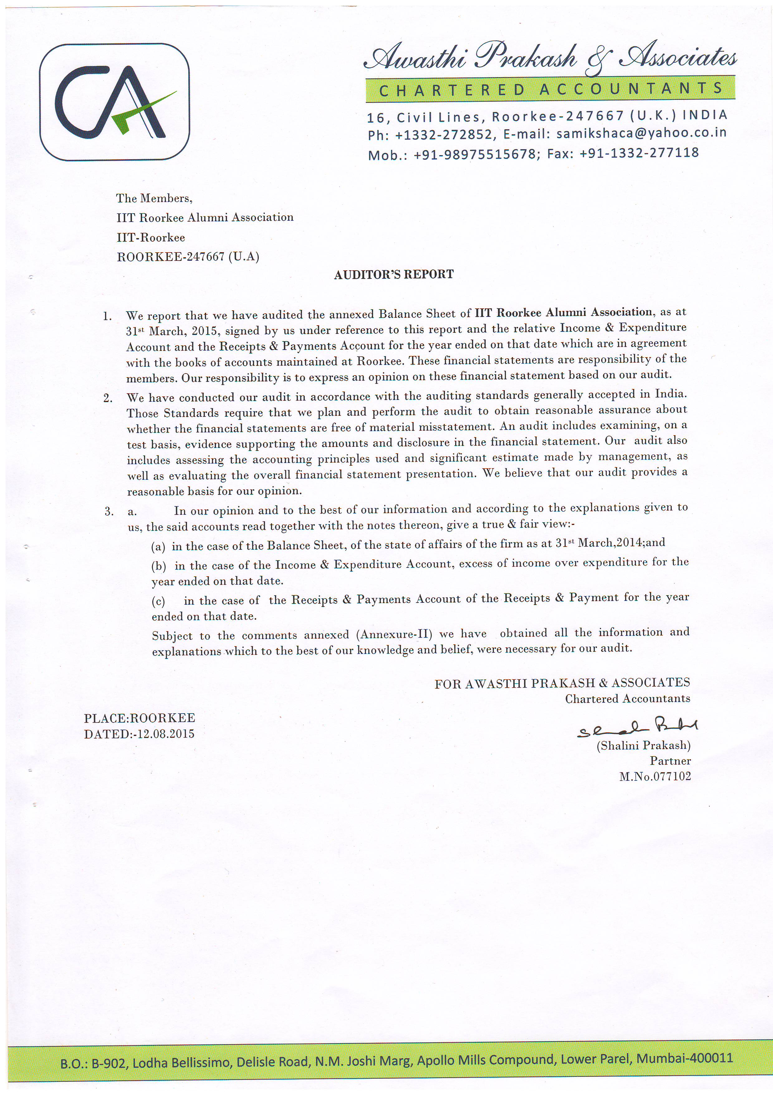
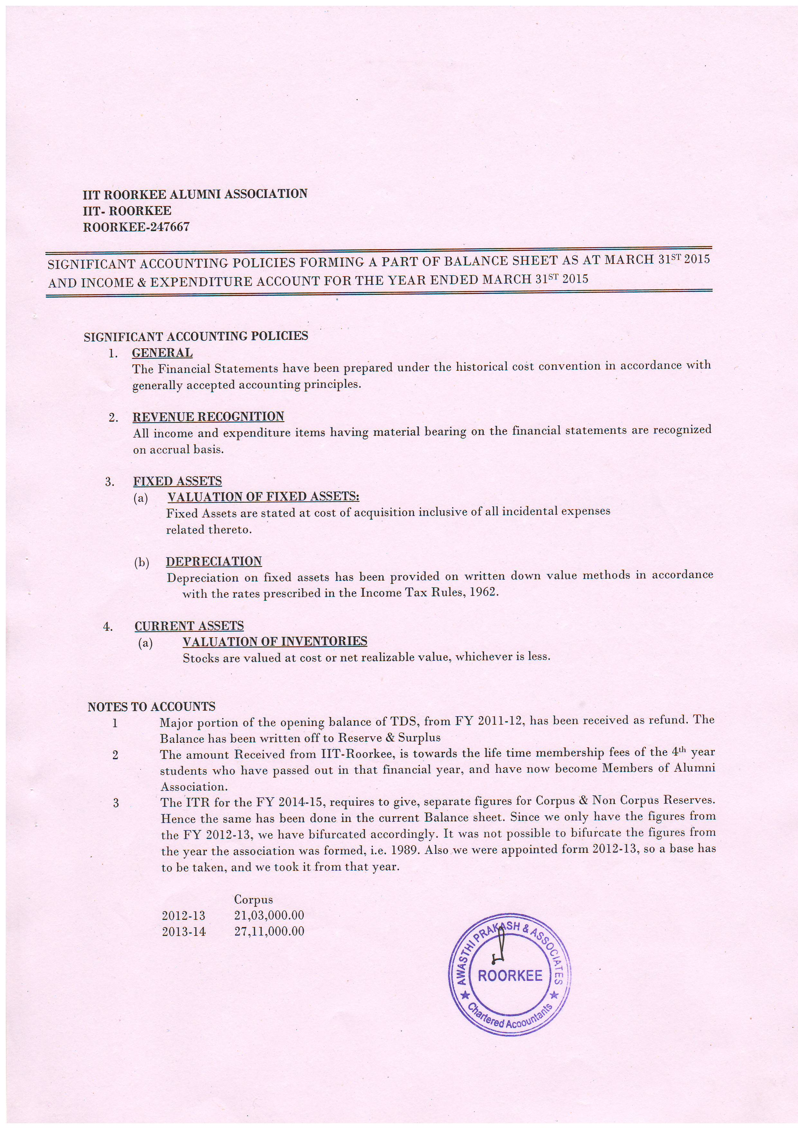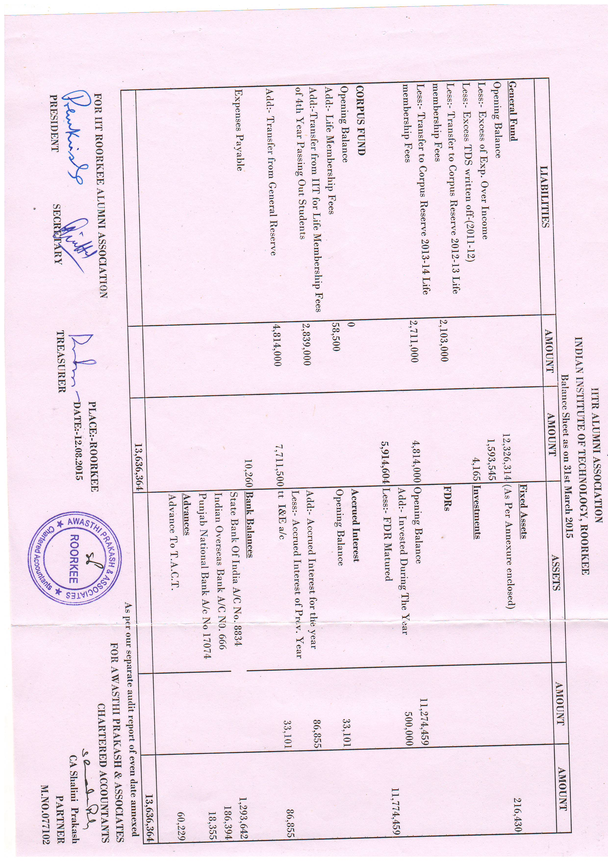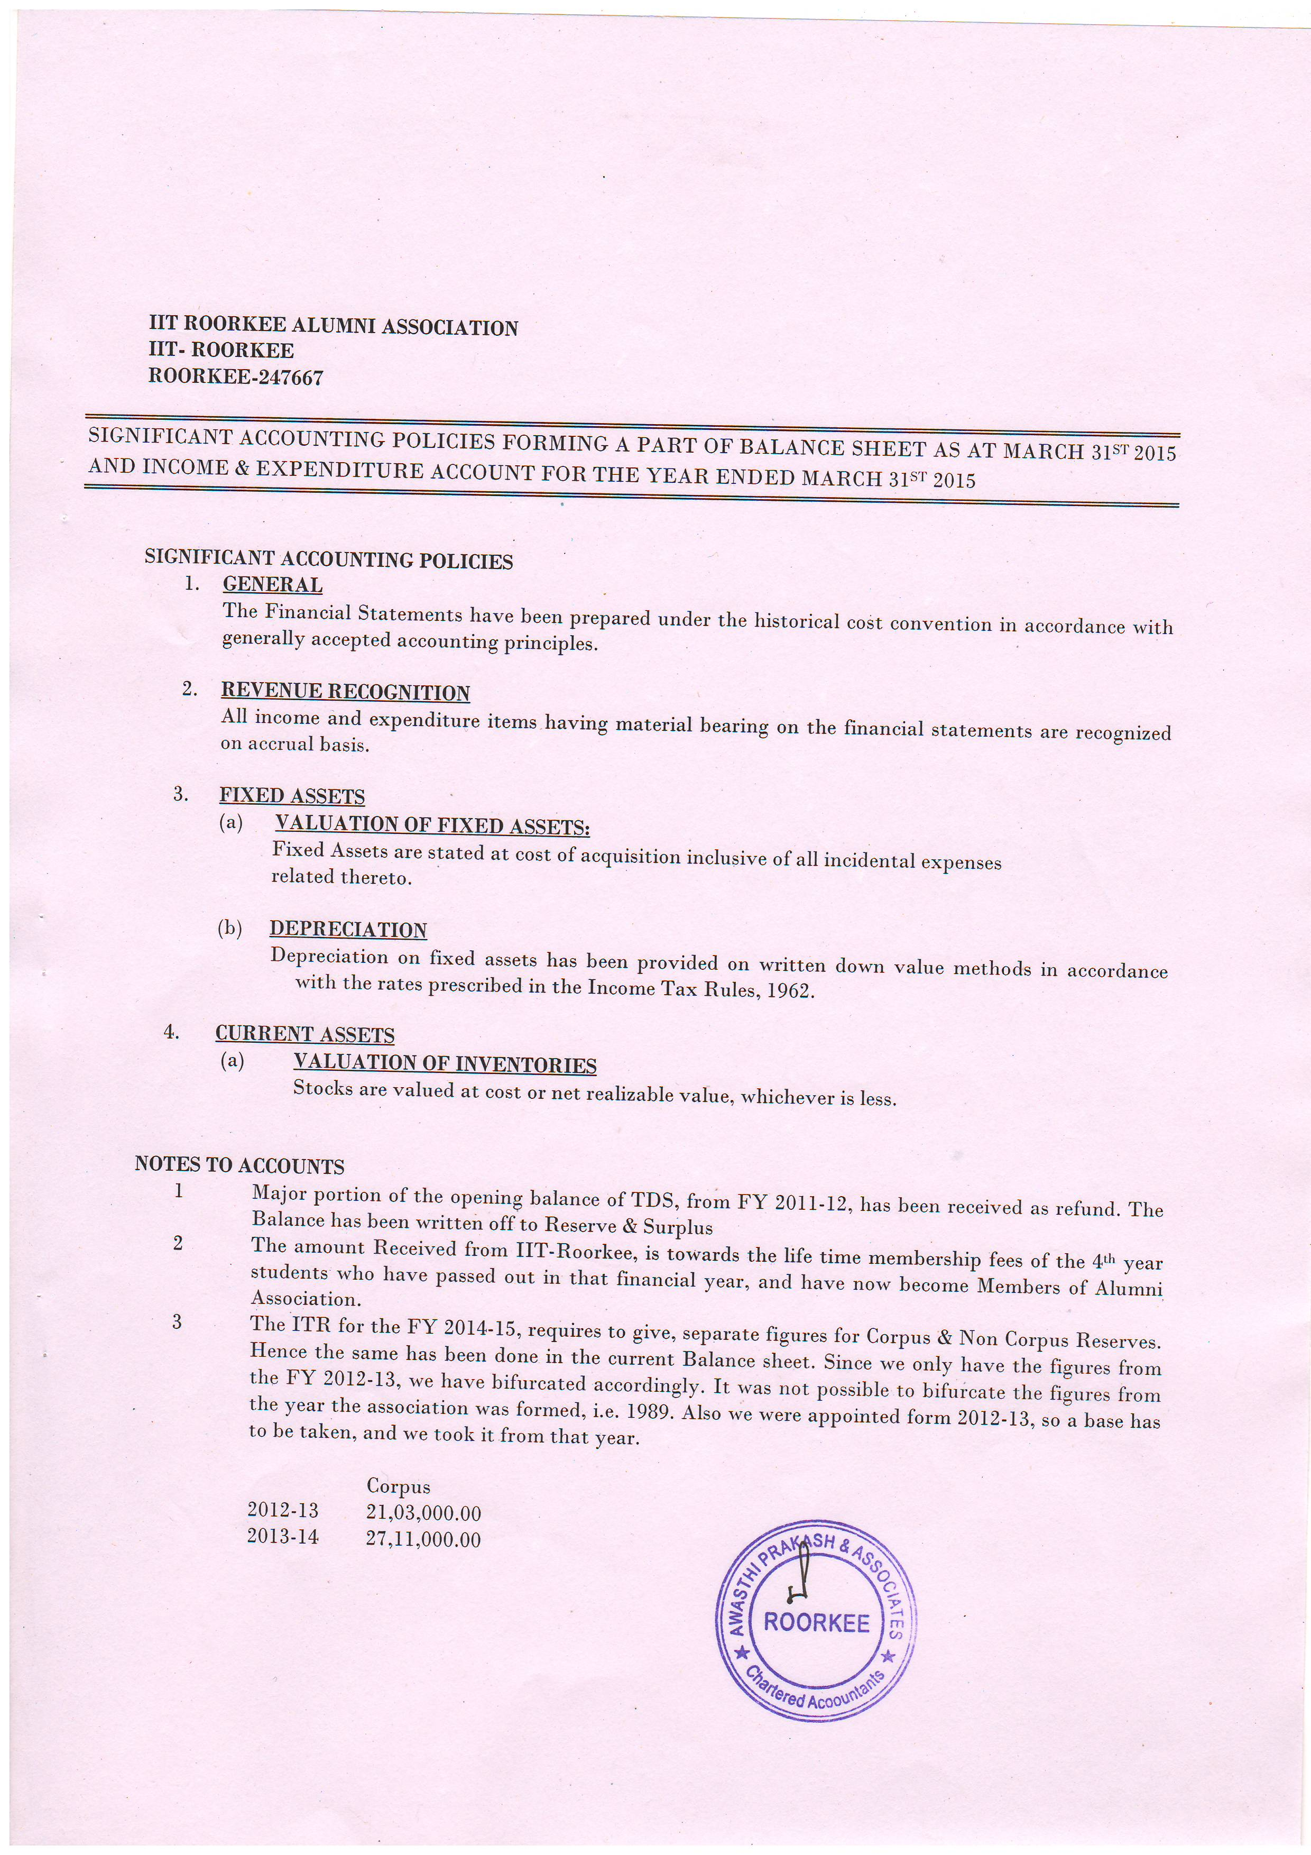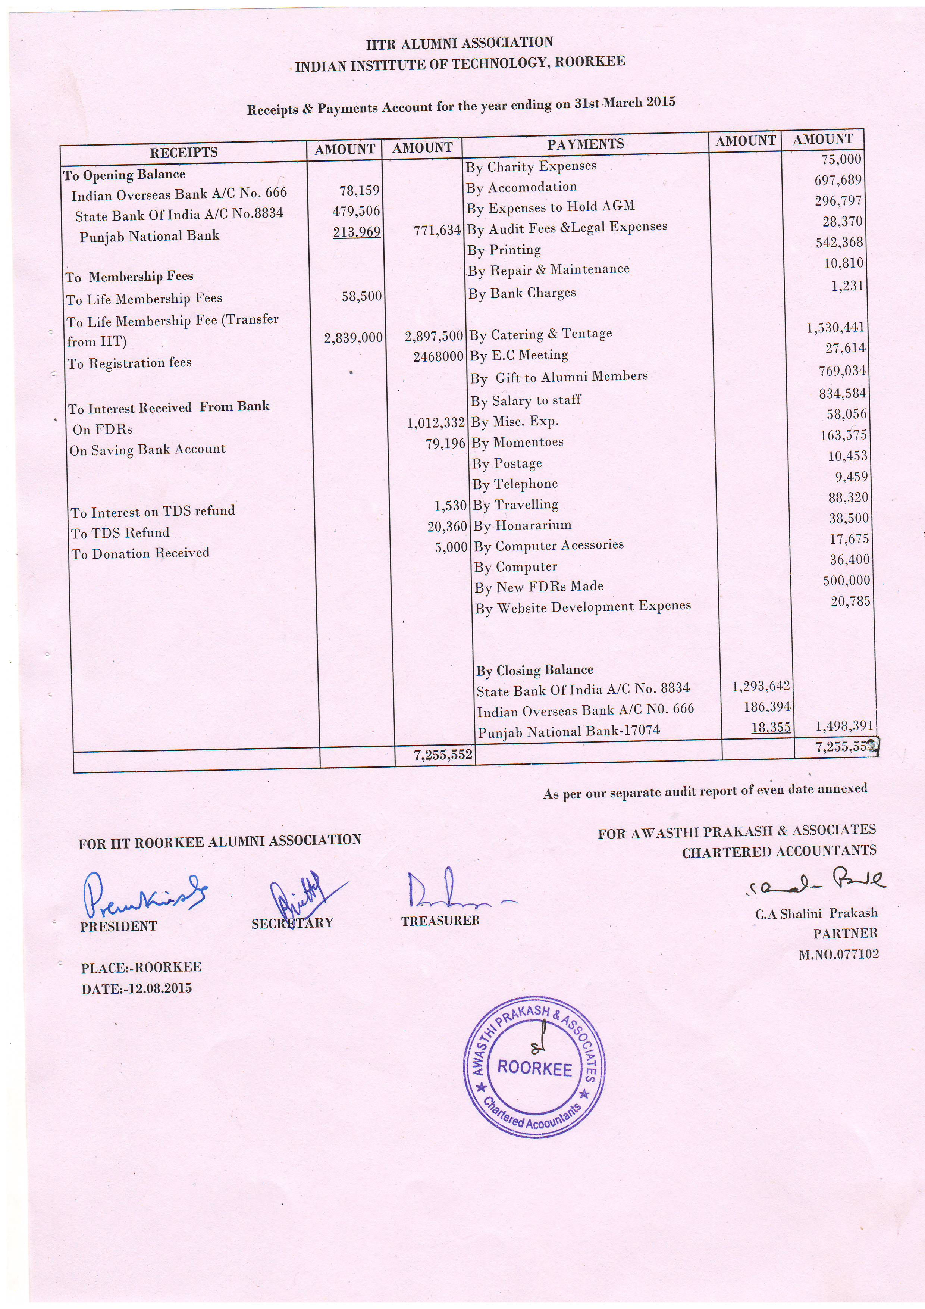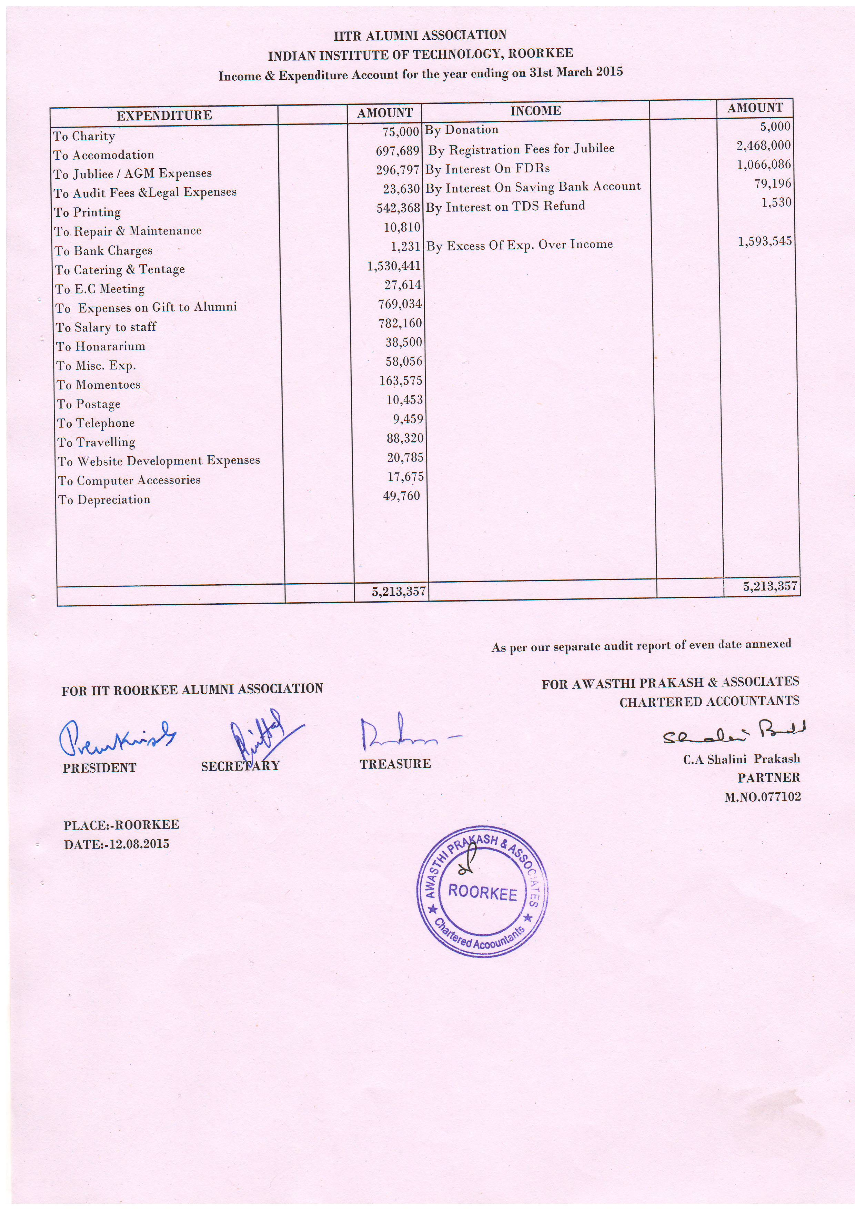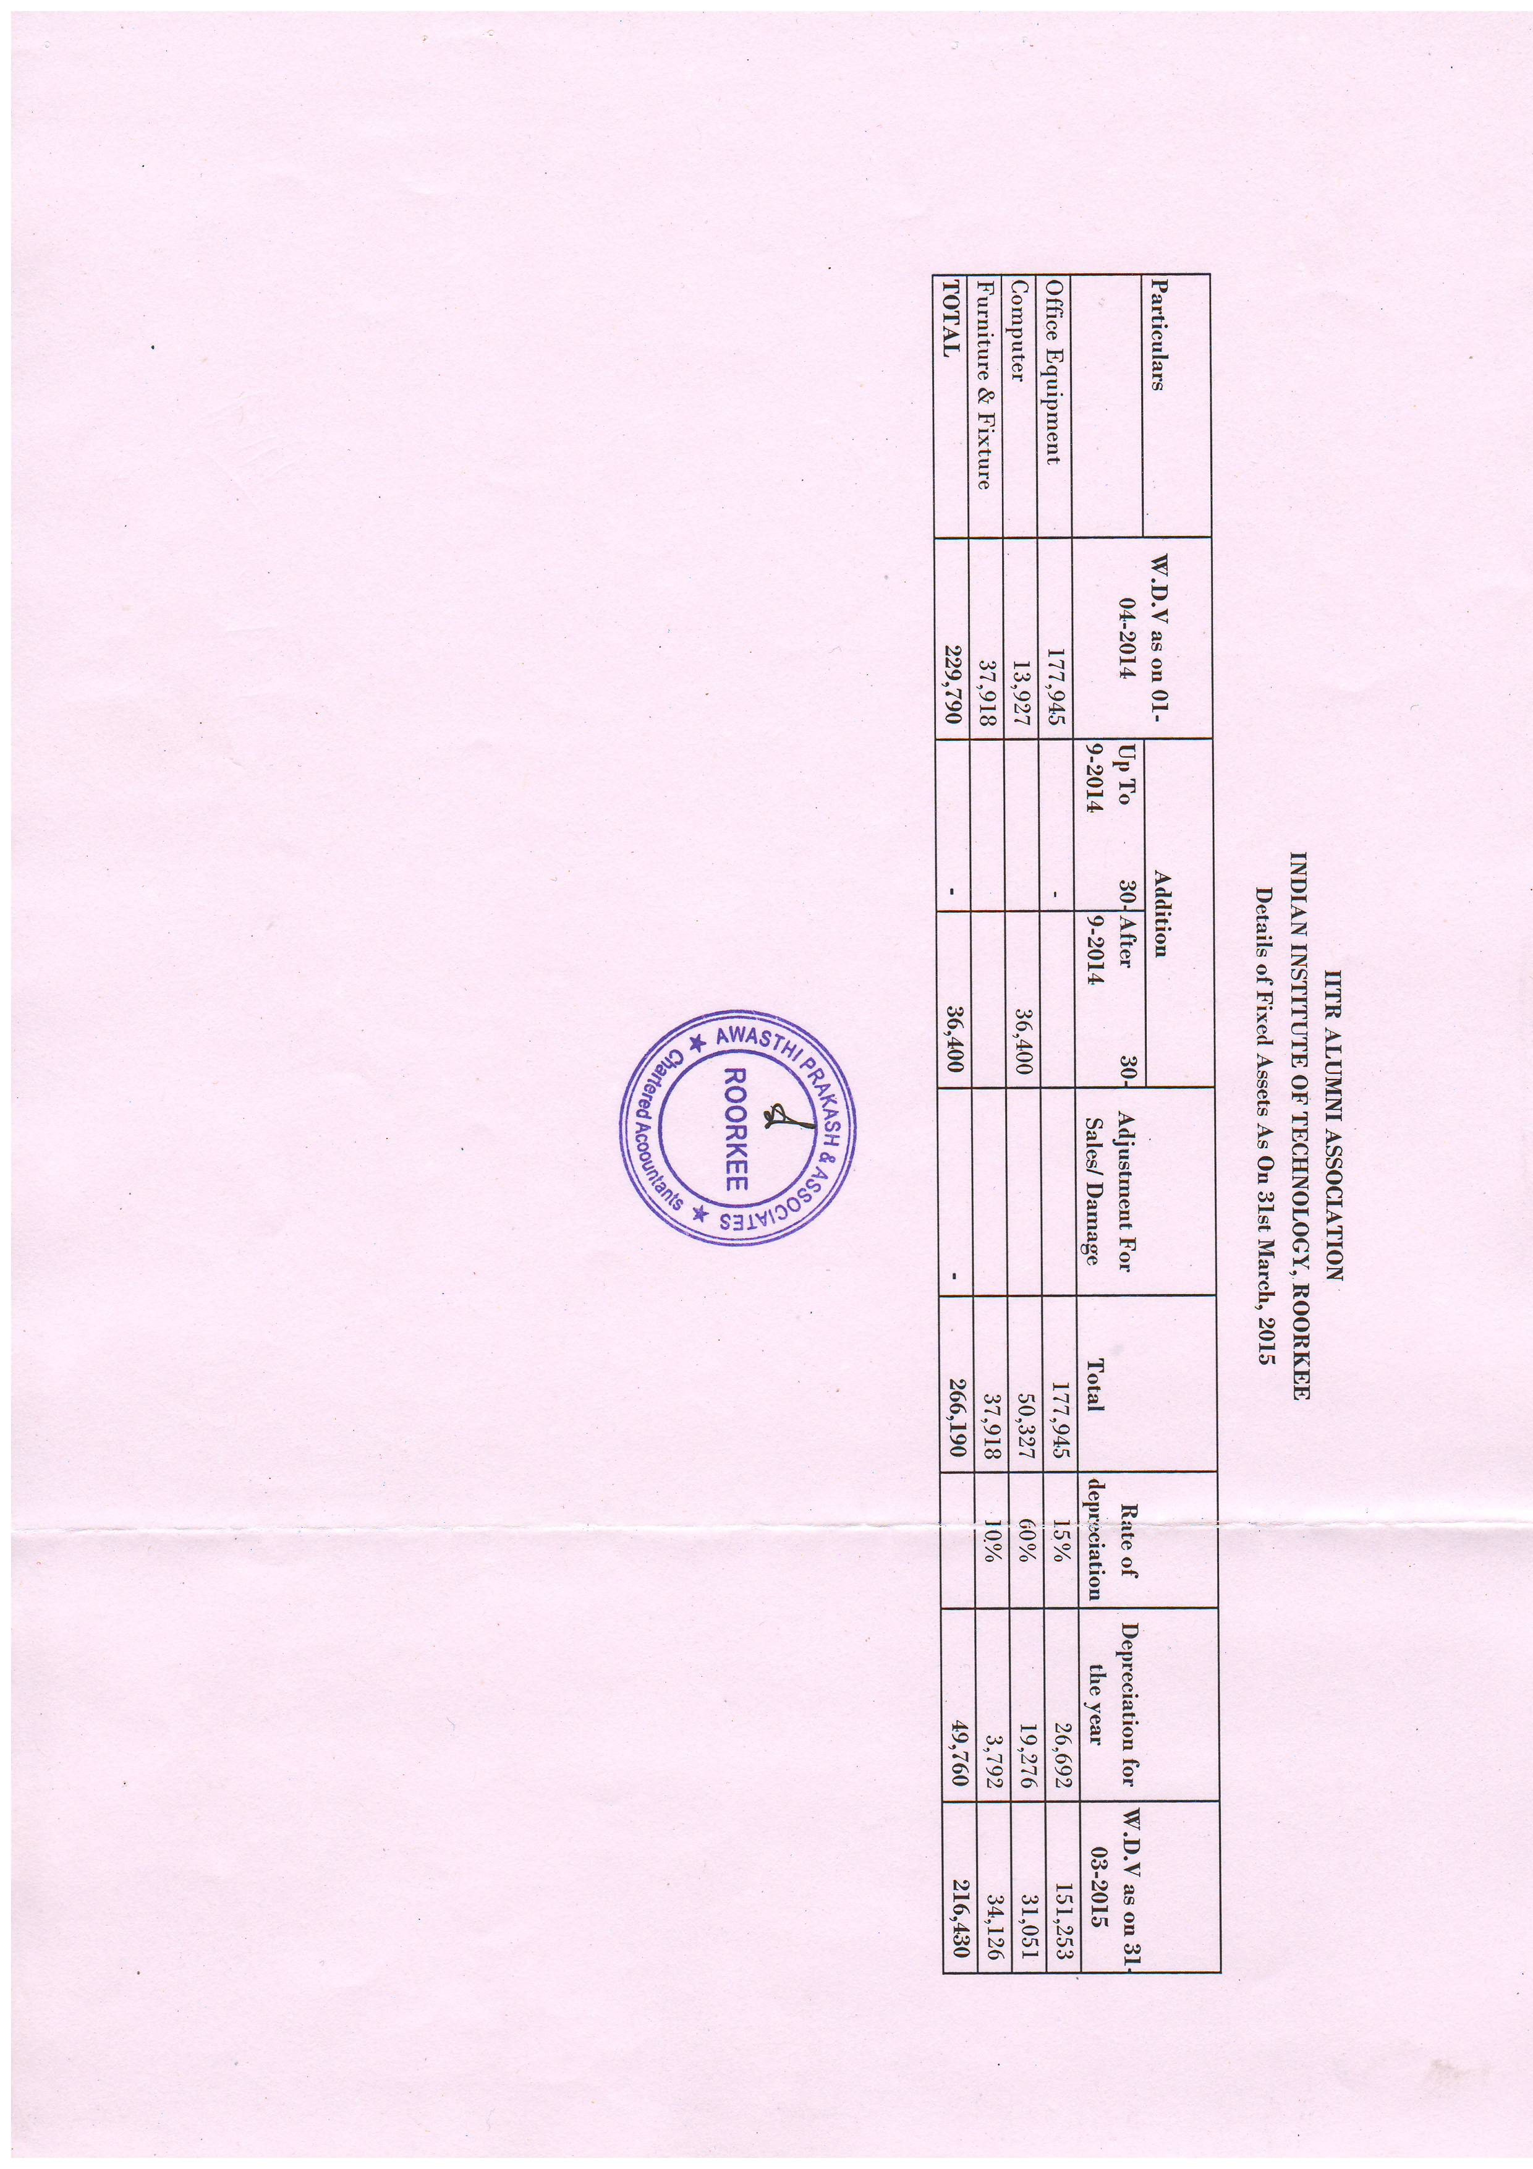

66.7 To consider the appointment of the Auditor for the financial year 2015-2016.

The EC has proposed that chartered Accountant appointed for the financial year 2015-16 may be continued for the financial year 2015-16 also. Submitted for the approval of members of AGBM.

66.8 To consider the Budget for the year 2016 – 2017

I request you to kindly see your report for its printed version. If anyone has some suggestion, please intimate us.

Provisional Budget for the Year 2016-17
Income |  | Expenditure
Membership fee | 25,00,000 | Printing & Stationery+ Year Book | 1,100,000
Interest | 14,00,000 | Postage | 30,000
Registration fee | 35,00,000 | Mementos & souvenir | 8,00,000
 |  | Transport/Travelling | 80,000
 |  | Salary of staff /Honorarium | 8,00,000
 |  | Hospitality | 9,50,000
 |  | Boarding & Lodging | 1,050,000
 |  | Audit & Contingencies | 35,000
 |  | Telephone & FAX | 15,000
 |  | AGM | 2,00,000
 |  | Activities with Local Chapters | 2,50,000
 |  | PAN IIT | 50,000
 |  | Photo identity cards for members | 40,000
 |  | Webpage including office Assistant wages | 2,50,000
 |  | Office & Computer & peripherals Maintenance | 1,50,000
 |  | Alumni Lecture series | 1,50,000
 |  | Charity/Contributions to National Activities/students | 2,50,000
 |  | Consumables / Contingencies Miscellaneous | 5,00,000
 |  | Savings | 7,00,000
Total | 74,00,000 |  | 74,00,000

  - Any other item with the permission of the Chair

Annexure-1
Minutes of the 65th Annual General Body Meeting (AGBM) of the IIT Roorkee Alumni Association held on November 05, 2014.
The 65th AGBM was held on November 05, 2014 at 4.30 PM in the O.P. Jain Auditorium of Civil Engineering Department. Over 200 Alumni were present. Among them were 120 Silver Jubilee Alumni of 1989 batch & B. Arch 1990 batch and Non Jubilee alumni were present.
At the outset, the House condoled the sad demise of the following alumni
Shri V.R. Vaish (1941), Er. Gauri Shankar, (BE Civil 1953), Mr. O. P. Garg (Diploma 1954), Mr. Dinesh Narain Sarbahi (Batch 1960), Er. Narendra Patni (Batch 1963), Dr. Renu Bhargava (Batch 1971), Prof. Yogesh Chandra (ME 1973)
The members stood in silence for two minutes to pay their homage to the departed souls.
The meeting was adjourned for a while and reassembled to take up the agenda further as given below.
The meeting started with the recitation of Kulgeet.
Er. S.C.Goel, Vice President welcomed the members of the Alumni Association of Silver Jubilee (1989 batch and B. Arch 1990 batch) as well as Non-Jubilee Alumni.

  - The minutes of the 64th AGBM held on November 18, 2013 were confirmed. The minutes were considered and approved as such.

  - Prof. Prem Krishna, the President welcomed the Silver Jubilee Alumni and non-Jubilee Alumni and presented his address.

  - Felicitation of Silver Jubilee Alumni (1989 Batch and B. Arch 1990 Batch):
The alumni were felicitated by the President by presenting a memento to each of them.

At the end of this ceremony few of the alumni gave their responses, which included the old memories of their stay at the University of Roorkee as well as some feedback suggestions for furthering the interaction between IITR and the alumni.

  - The Annual Report for the period from November 01, 2013 to October 31, 2014 was presented and considered. The report was adopted by the house.

  - The Audit report giving the Audited Account for the period from April 1, 2013 to March 31, 2014 was considered and adopted.

  - Appointment of the auditor for the financial year 2014-15 was considered. It was resolved that the same Chartered Accountant as in Financial Year 2013-14 i.e. M/s Awasthi Prakash & Associates, Roorkee be continued for Financial Year 2014-15 also.
  - Budget for the year 2015-16 was considered and was approved.

65.8 (a) As Prof. Pradipta Banerji, Director, IIT Roorkee could not attend the AGBM due to unavoidable circumstances, Prof. Sandeep Singh, Dean Alumni Affairs and International Relations presented the message on behalf of Director, IIT Roorkee
(b) A Presentation about IIT Roorkee was given by Prof. S.P. Gupta, Deputy Director, IIT Roorkee
  - The house approved the by-laws of IIT Roorkee Alumni Association pertaining to Local Chapters.
  - Announcement of President and Honorary Secretary nominated for the year 2015-16 was done by Prof. Sandeep Singh, the Dean Alumni Affairs and International Relations, IITR. He announced that the EC in its last meeting held on October 31, 2014 has nominated / elected the following for year 2015-16.

- Prof. Prem Krishna as the President
- Dr. Achal Kumar Mittal as the Honorary Secretary

  - Election of the Executive Committee for the year 2015-16. The returning officer, Prof. Rajesh Chandra announced the outcome of the election held on November 05, 2014. The election results are given in Annexure-2.

  - ROBA QUIZ: Dr. Achal Kumar Mittal, who conducted the ROBA Quiz, declared, the names of winners of ROBA Quiz. Prof. Prem Krishna, President presented the memento to the winners.

  - Under Any other item Dr. Achal Kumar Mittal, Joint Secretary gave a presentation on the queries raised by some alumni. The details of the presentation is in Annexure-3.

The secretary proposed vote of thanks. The meeting ended with the recitation of National Anthem.

Pradeep Kumar
Honorary Secretary

Annexure -2

The results of the Elections to the executive Committee for the year 2015-16

Post | Name | Year | Batch
Vice President(1) | Prof. V. K. Gupta | 1971 | ME (Civil)
Joint Secretary (1) | Dr. R. D. Garg | 1989 | Civil
Treasurer (1) | Er. Dinesh Singh Pawar | 1993 | Mechanical
Members (15) | Er. Narendra Singh | 1986 | ME (Mechanical)
 | Er. Mayank Kumar Tilak | 1986 | Civil
 | Er. Naresh Chandra Garg | 1963 | Civil
 | Dr. A.K. Gupta | 1971 | Chemical
 | Er. Nand Kishore Sharma | 1979 | Civil
 | Ar. B.D. Mittal | 1969 | Architecture
 | Er. H.K. Verma | 1988 | CST
 | Dr. Rajnish Garg | 1989 | Mechanical
 | Er. Pradeep Kumar Bansal | 1989 | Mechanical
 | Er. Sudhir Kumar Mittal | 1966 | Civil
 | Dr. Bhavana Sindhu | 1987 | Humanities
 | Prof. P.P. Agarwal | 1983 | ME (WRD)
 | Mrs. Surjeet Sharma | 1979 | Electrical
 | Dr. Satyendra Mittal | 1988 | ME Civil
 | Er. Dinesh Kumar Garg | 1992 | Biotech

Annexure – 3

Some points regarding the functioning of IITRAA raised by a few alumni members were clarified in detail to the house during the AGBM.

Point 1: Notice for AGBM to all Members

The house was informed that the notice of AGBM is sent to all members as per all databases available with IITRAA.

The house appreciated it and desired to enhance the database. It was further informed to the house that the continuous efforts are being made to update the database.

Point 2: Fees collected from students and remittances to IITRAA

Regarding this issue it was informed to the house that IIT Roorkee collects security deposit from its students. At the time of passing out, they are transferring the alumni life membership fee to IITRAA. Further, the details of year wise transfer of amount have been sought from accounts and academic sections of IITR.

House appreciated the efforts and expressed satisfaction.

Point 3: Break up of Honorarium and names of recipients

A detailed table has been presented during AGBM giving names and amount paid yearwise as honorarium. It was explained to the house that honorarium includes payments to three staff hands assisting IITRAA office i.e. Mr Atin Sharma, Mr R K Sharma and Mr Rajeshwar. Apart from this, the honorarium has been paid to Workers/Malis of sports ground, KIH Staff, etc. who help IITRAA in smooth functioning of Jubilee meets. No honorarium has been paid to any of the EC members.

The house noted the clarification.

Point 4: Recovery from TACT:

The house was informed that the matter was discussed and closure of TACT was approved by earlier EC on 29/03/2014. Accordingly the balance amount of 31995/- was deposited in the Alumni Association account on 31/03/2014.The TACT account has been closed.

The house noted the clarification.

Point 5: FCRA Regulations of Govt. of India

The house was informed that Registration for FCRA has been initiated and the approval is awaited.

House expressed satisfaction.

Point 6: Entertaining Foreign Participants in Jubilees

IITRAA has taken up this issue with IIT Roorkee. It was informed that for persons of Indian origin no special permission is required. Dean Alumni and International Relations confirmed this to the house.

The house noted the clarification.

Point 7: Heritage Foundation of USA

It was informed to the house that IITR Heritage Foundation of USA is an autonomous body formed by some alumni and is laudable work. However it has no formal linkages with IITRAA.

The house noted the clarification.

House appreciated the efforts of the EC in bringing a detailed reply to the concerns raised by a few alumni members, and resolved that these matters be considered as closed. IITRAA should move forward and devote time and energy to issues concerned with the betterment of alumni and Alma mater.

IITR ALUMNI ASSOCIATION

PRESIDENTS AND SECRETARIES
Year | President | Secretary
2015 | Prem Krishna | Achal Mittal
2014 | Prem Krishna | Pradeep Kumar
2013 | J. L. Gaindhar | Pradeep Kumar
2012 | J. L. Gaindhar | N. K. Samadhiya
2011 | P.K. Pande | N. K. Samadhiya
2009-10 | D. V. Singh | Ashok K. Ahuja
2007-08 | R. K. Singh | Manoj K. Arora
2004-06 | V. K. Agnihotri | R. P. Maheshwari
2002-03 | Pradip Baijal | S. K. Ghosh
1998-2001 | H.S. Agarwal | A. K. Mathur
1997 | D.V. Singh | V. K. Goel
1996 | D.V. Singh | Surendra Kumar
1995 | Ashok Bhatnagar | Surendra Kumar
1994 | S.K. Khanna | S. C. Handa
1993 | R.P. Singhal | S. C. Handa
1992 | Rajendra Prakash | S. C. Handa
1991 | Harish Chandra | V. P. Bansal
1990 | Raj Kumar Jain | Ashok K. Jain
1989 | Bhupal Singh | Ashok K. Jain
1988 | G.C. Agarwal | Ashok K. Jain
1987 | G.C. Agarwal | S. K. Mittal
1986 | R.C. Mangal | S. K. Mittal
1985 | Vijendra Singh | S. K. Mittal
1984 | K.M.Maheshwari | V. K. Tiwari
1983 | O.P. Jain | V. K. Tiwari
1982 | D.R. Singh | A. K. Gupta
1980-81 | Dinesh Mohan | A. K. Gupta
1979 | Hari Krishna | A. K. Agarwal
1978 | V.R. Vaish | A. K. Agarwal
1977 | K..C. Goyal | V. Charan
1976 | J.S. Dhillon | Satish Chandra
1975 | N.D. Gulhati | Shamsher Prakash
1974 | Jivan Datt | Shamsher Prakash
1973 | S.K. Jain | R. N. Agrawal
1972 | H.G. Verma | R. N. Agrawal
1971 | Jai Krishna | A. S. Arya
1970 | S. C. Katoch | A. S. Arya
1969 | J. P. Mital | M. K. Singhal
1968 | Baleshwar Nath | Satish Chandra
1967 | D. B. Anand | Satish Chandra
1966 | D. S. Nag | Satish Chandra
1965 | D. C. Baijal | Rajendra Prakash
1964 | H. P. Sinha | Rajendra Prakash
1963 | Yadav Mohan | Rajendra Prakash
1962 | G.K. Agarwal | K. V. Mital
1961 | Kanwar Sain | K. V. Mital
1960 | P.L. Verma | Dinesh Mohan
1959 | Karnail Singh | Dinesh Mohan
1958 | Ghananand Pandey | Dinesh Mohan
1957 | H.K.L. Sethi | S. N. Gupta
1956 | K.N. Kathpalia | S. N. Gupta
1955 | M.S. Bisht | S. N. Gupta
1954 | M.S. Mathur | S. N. Gupta
1953 | Balbir Singh | S. N. Gupta
1952 | A.N. Khosla | S. N. Gupta
1951 | L.P. Misra | S. N. Gupta
1950 | C.A. Hart | Jai Krishna
1949 | N.N. Chakravarti | Jai Krishna
1947-48 | B.D. Puri | Jai Krishna
1946 | G. Lacey | Jai Krishna
1940-45 | M.G. Sardana | Jai Krishna

