65th ANNUAL GENERAL BODY MEETING

NOVEMBER 05, 2014

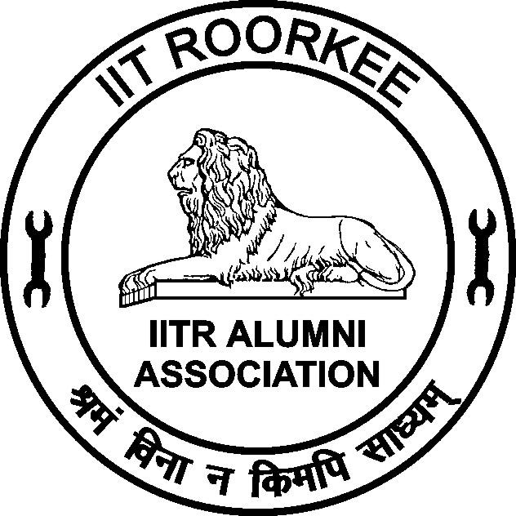

IITR ALUMNI ASSOCIATION
INDIAN INSTITUTE OF TECHNOLOGY ROORKEE
(Formerly University of Roorkee)
ROORKEE – 247 667

EXECUTIVE COMMITTEE 2014 – 2015
Prof. Prem Krishna
President
Er. Subhash Chandra Goel
Vice President
Dr. Pradeep Kumar
Honorary Secretary
Dr. Achal Kumar Mittal
Joint Secretary
Er. Dinesh Pawar
Treasurer
Prof. Sandeep Singh
Dean, Alumni Affairs
Prof. N. K. Samadhiya
Immediate Past Secretary
Elected Members

Prof. S. K. Agrawal | Er. M.K. Tilak | Er. Narendra Singh
Er. Ravindra Kumar Sinha | Prof. P.P. Agarwal | Er. H. K. Verma
Prof. Sarla Sahu | Dr. Prabhat Singh | Er. N. K. Pant
Er. Ajay Kumar Agarwal | Er. N.C. Garg | Er. Sandeep Sharma
Dr. R. D. Garg | Er. Rajnish Garg | Dr. Bhavana Sindhu
Nominated Members
Prof. A. K. Mathur | Prof. H. Sinvhal
Agenda for 65th Annual General Body Meeting of IITR Alumni Association

- Kulgeet
- Welcome address by Secretary
- Obituaries
- Welcome Speech - by Vice President

  - Confirmation of minutes of the 64th AGBM held on November 18, 2013
- Introduction of President- By Honorary Secretary
  - Presidential Address by Prof. Prem Krishna, President
  - Felicitation of Silver Jubilee Alumni (1989 Batch, B.Arch. 1990 batch)
  - To consider Annual Report for the period from November 01, 2013 to October 31, 2014
  - To consider the Audited Accounts for the period from April 1, 2013 to March 31, 2014
  - To appoint the Auditor for the financial year 2014 – 2015
  - To consider the Budget for the year 2015 – 2016.
  - Address by the Director/Dean - Alumni Affairs, IIT Roorkee.
  - To consider the bye laws of IIT Roorkee Alumni Association pertaining to Local Chapters
  - Announcement of President and Honorary Secretary elected for the year 2015-16
  - Election of the Executive Committee members for the year 2015-16
  - Declaration of ROBA Quiz Prize winner
  - Any other item with the permission of the Chair
- Vote of Thanks
- National Anthem

  - Confirmation of the minutes of the 64th Annual General Body Meeting(AGBM) of the IIT Roorkee Alumni Association (IITRAA) held on November 18, 2013 at 4:30 PM in the O.P. Jain Auditorium of Civil Engineering Department of IIT Roorkee.

Minutes of the 64th Annual General Body Meeting (AGBM) of the IIT Roorkee Alumni Association held on November 18, 2013.
The 64th AGBM was held on November 18, 2013 at 4.30 PM in the O.P. Jain Auditorium of Civil Engineering Department. Over 200 Alumni were present. Among them were 115 Silver Jubilee Alumni of 1988 batch & B. Arch 1989 batch and Non Jubilee alumni were present.
The meeting started with the recitation of Kulgeet.
Dr. Pradeep Kumar, the Honorary Secretary welcomed the members of the Alumni Association of Silver Jubilee (1988 batch and B. Arch 1989 batch) as well as Non-Jubilee Alumni.
At the outset, the House condoled the sad demise of the following alumni
- Prof. P.V. Indiresan (Ex-Faculty E & C Engineering Department)
- Col. D. B. Nayar, Retd. BE Civil 1958
- Prof. U. C. Kothyari (Faculty Member, Civil Engineering Department)
- Prof. Arun Kumar Gupta (Faculty Member, E & C Engineering Department)
- Prof. S.R. Gupta (Alumnus 1964 Batch, Mechanical, as well as faculty of M & I Engineering Department)
The members stood in silence for two minutes to pay their homage to the departed souls.
The meeting was adjourned for a while and reassembled to take up the agenda further as given below.
  - The minutes of the 63rd AGBM held on November 25, 2012 were confirmed. The minutes were considered and approved as such.

  - Prof. J. L. Gaindhar, the President welcomed the Silver Jubilee Alumni and non-Jubilee Alumni. He exhorted them to always remain connected with their Alma Mater. They should give their feedback so that the IITR can always remain up-to-date with the latest happenings in the industrial area both in India as well as globally.

  - Felicitation of Silver Jubilee Alumni (1988 Batch and B. Arch 1989 Batch):

The alumni were felicitated by the President by presenting a memento to each of them.

At the end of this ceremony few of the alumni gave their responses, which included the old memories of their stay at the University of Roorkee as well as some feedback suggestion for furthering the connect between IITR and the alumni.

  - The Annual Report for the period from November 15, 2012 to October 31, 2013 was presented and considered. The report was adopted by the house.

  - The Audit report giving the Audited Account for the period from April 1, 2013 to March 31, 2013 was considered and adopted.

  - Appointment of the auditor for the financial year 2013-14 was considered. It was resolved that the same Chartered Accountant as in Financial Year 2011-12 i.e. M/s Awasthi Prakash & Associates, Roorkee be continued for Financial Year 2012-13 also.

  - Budget for the year 2014-15 was considered and was approved.

(a) The address by Prof Pradipta Banerji, The Director:
Prof. Banerji had welcomed and addressed the Silver Jubilee Alumni at 10.00 AM in the Senate Hall because he had to depart from Roorkee for some urgent meeting in the evening.

The Director gave very encouraging news about various developmental projects being undertaken in IITR. The most significant project was the collaboration of the Japanese Government with IITR.

(b) Prof. S. C. Sharma. Dean Alumni Affairs, IIT Roorkee addressed the Jubilee Alumni and elaborated various new developments with regard to orientation of freshers in IITR for one week. He also announced four Distinguished Alumni Awards to be given on Alumni Day on November 25, 2013. The list of the awardees is given in Appendix -1.

  - Announcement of President and Honorary Secretary nominated for the year 2014-15 was done by Prof. S. C. Sharma, the Dean Alumni affairs, IITR. He announced that the EC in its last meeting held on October 26, 2013 has nominated the following for year 2014-15.

- Prof. Prem Krishna as the President
- Dr. Pradeep Kumar as the Honorary Secretary
The President-Designate Prof. Prem Krishna addressed the Silver Jubilee Alumni also.
  - Election of the Executive Committee for the year 2014-15. The returning officer, Prof. V. K. Gupta announced the outcome of the election held on November 18, 2013. The election results are given in Appendix-2.

  - ROBA QUIZ: Unfortunately ROBA Quiz could not be held, hence no prize was awarded.

  - There was no specific point raised under any other item.

The secretary gave vote of thanks. The meeting ended with the recitation of National Anthem.

Pradeep Kumar
Honorary Secretary

65.2 Presidential Address by Prof. Prem Krishna, President, IITR Alumni Association

Distinguished Guests; Dear Alumni, particularly the Silver Jubilee alumni, and, their families; Ladies and Gentleman:
I welcome you all to this Annual General Meeting of the Alumni Association. . I particularly wish to felicitate our Silver Jubilee Alumni of the 1989 batch, who are coming to the campus 25 years after they left the portals of this great institution. Those of our alumni, who are visiting the campus after many years would have noticed quite a few changes. In fact our great Alma Mater has been in a progressive, dynamic mode throughout its long history since 1847 – the longest history in engineering education in the Country, and, perhaps the third longest in the world. Today it stands as one of the top few institutions of higher learning and research in engineering, science and technology in India, along with other much younger peers. This is a testimony to its sustained vitality and response to changing demands. The indelible Roorkee stamp binds its alumni now spread all over the world.
Along its long journey, the last two to three decades are somewhat special, in that the National scene has been undergoing a rapid change. Whereas the Institution, first in its University of Roorkee avatar, and subsequently the IIT Roorkee has kept pace, the growing challenges of National development are forever beckoning us for a greater role. The increasing population and rising aspirations for a better quality of life continue to mount ever increasing expectations from the engineering community. It is a matter of concern that the gap between what we have and what is needed (or going to be needed), particularly in terms of the infrastructure, housing, energy, health security, and so on, shows little signs of reducing. The engineering education base is expanding, but the average level of competency has doubtlessly diminished, sometimes bordering on being unacceptable. There is thus much that is needed to be done.
In this context it is noteworthy that currently the IITR Alumni Association has strength of about thirty thousand members. This is not a mere number but consists of the highly able alumni of our great institution. Thus the potential inherent in the membership of the IITR Alumni Association is very high. The challenge obviously is to look forward and tap this potential to strengthen the alma mater particularly, as well as, in general the National capabilities in engineering.
In order that the potential of the IITR Alumni Association can be utilised better, it is imperative that there is good connectivity. In this day and age of a strong e- media, this is not a problem, provided that a good database of contact information is available. Considerable effort is being made in this direction for the last few months and there is reasonable but slow progress so far.
Further, it is imperative that the IIT Roorkee and the IITR c, despite being two independent entities, pursue the common objective of connecting with the alumni, by working hand - in – hand. This, I am sure will enable us to achieve greater goals. I am happy to say that this sentiment persists, for which I wish to place my thankfulness to the Director, IIT Roorkee, Prof. Pradipta Banerji, the Dean Alumni Affairs and International Affairs, Dr. Sandeep Singh and the IITR Alumni Association Executive Council.
Before I end, I wish to congratulate the Silver Jubilee alumni and earnestly hope that they will carry fond memories of this re-union, and, return to the campus for their, Coral, Ruby, Golden, and, their Diamond Jubilees. I thank all of you who have come to attend this Annual General Body Meeting, and have given me a patient hearing.
Prem Krishna
President,
IITR Alumni Association (2014 – 15)

  - Felicitation of Silver Jubilee Alumni (1989 Batch, B.Arch. 1990 batch)

  - To consider the Annual Report for the period November 01, 2013 to October 31, 2014, by the Honorary Secretary

Annual Report of the IITR Alumni Association

It is a great pleasure to present the Annual Report of the IITR Alumni Association for the period of November 01, 2013 to October 31, 2014. This report presents various activities undertaken by the Association during given time frame.

Membership

The membership of the Alumni Association is increasing steadily. At present, we have about 28330 members as against 26300 members during the last year i.e. as on October 31, 2014. We have achieved these many members in about last 70 years since 1941. Looking into the present trend, it is likely to touch the magic number 50000 in coming next 15 years. If all remember, during your days of studies the number of students admitted was only 135-150, which are now a days about 1500 (which is approximately 10 Times).

Finance and Accounts

The audited accounts are printed on the following pages. As per the directions of the previous General Body of the Association, M/s Awasthi Prakash & Associates Chartered Accountant, Civil Lines, Roorkee have duly audited the accounts.

AGBM and other Activities

Jubilee Alumni Meet - 2013

Silver Jubilee Alumni Meet-2013 and Diamond & Golden Jubilee Alumni Meet - 2013 were celebrated with great enthusiasm on 18th & 19th November, 2013 and 24th & 25th November, 2013. There were 7 Diamond Jubilee Alumni (1952 batch), 63 Golden Jubilee Alumni (1963 batch) and 115 Silver Jubilee Alumni (1988 batch and B. Arch 1989 batch) who attended the meet with their families. Some of the alumni had come for the first time after graduating from the erstwhile University of Roorkee.

All the Jubilee Alumni along with their families had separately met their respective batch mates with great zeal and nostalgia. They enjoyed games on Lal Bahadur Shastri Stadium with great gusto.

On November 18, 2013, the Silver Jubilee Alumni of 1988 and 1989 (B. Arch.) batches and on November 24, 2012, the Diamond & Golden Jubilee Alumni of 1953 & 1963 batches respectively were felicitated and presented with mementoes in the O. P. Jain Auditorium of Civil Engineering Department.

On November 25, 2013 the IIT Roorkee celebrated “The Alumni Day” near the Institute Flag, which commemorated the Foundation Day of Thomason College and Charter Day of University of Roorkee. Seven Distinguished Alumni Awards were presented. All the Jubilee alumni also witnessed this great event.

On 18th November, 2013, the 64th Annual General Body Meeting of the Association was held in O.P. Jain Auditorium and was attended by over 200 members. The President of the Association in the presence of Prof. Pradipta Banerji, the Director, IIT Roorkee, welcomed the members and the Jubilee Alumni who had graced the function.

Annual General Body Meeting

The 64th Annual General Body Meeting of the Association was held in the evening of 18th November, 2013 in O.P. Jain Auditorium and was attended by over 200 members. The President of the Association welcomed the members of the association and the Jubilee Alumni who had graced the function. A large number of student volunteers participated in Jubilee function. Visiting alumni appreciated their enthusiasm and participation.

The Alumni of 1988 and 1989 (B. Arch) batches were felicitated on this occasion for completing Silver Jubilee of their graduation. Similarly, Diamond Jubilee Alumni (1953) and Golden Jubilee (1963) were also felicitated.

Programme for Accompanying Spouses

On Nov. 18, 2013 an interesting parallel session for all the accompanying spouses and children has been organized in the Khosla International House (earlier Afro-Asian Hostel). In this session, an informal cultural function was arranged, where the spouses narrated interesting stories regarding their husbands and their emotional involvement with Roorkee. Accompanying children cherished this occasion with great enthusiasm.

Anushruti Programme

Both the Jubilee Alumni visited Anushruti (formerly Roorkee School for the Deaf) and many of them did noble thing of donations for the school.

Website

The Alumni Association has been able to establish its own independent website. A monthly e-newsletter is being sent to those members whose email addresses are available with us. The website is www.iitraa.in .

Acknowledgements

I am extremely grateful to Prof. Prem Krishna, President, Prof. Pradipta Banerji Director IITR and the Working President, for their guidance, support and encouragement received by me during the period.

I am thankful from the bottom of my heart to all the members of the Executive Committee and fellow Alumni from the Institute and all the local chapters those who have helped me in the activities of the Alumni Association.

(Pradeep Kumar)
Honorary Secretary

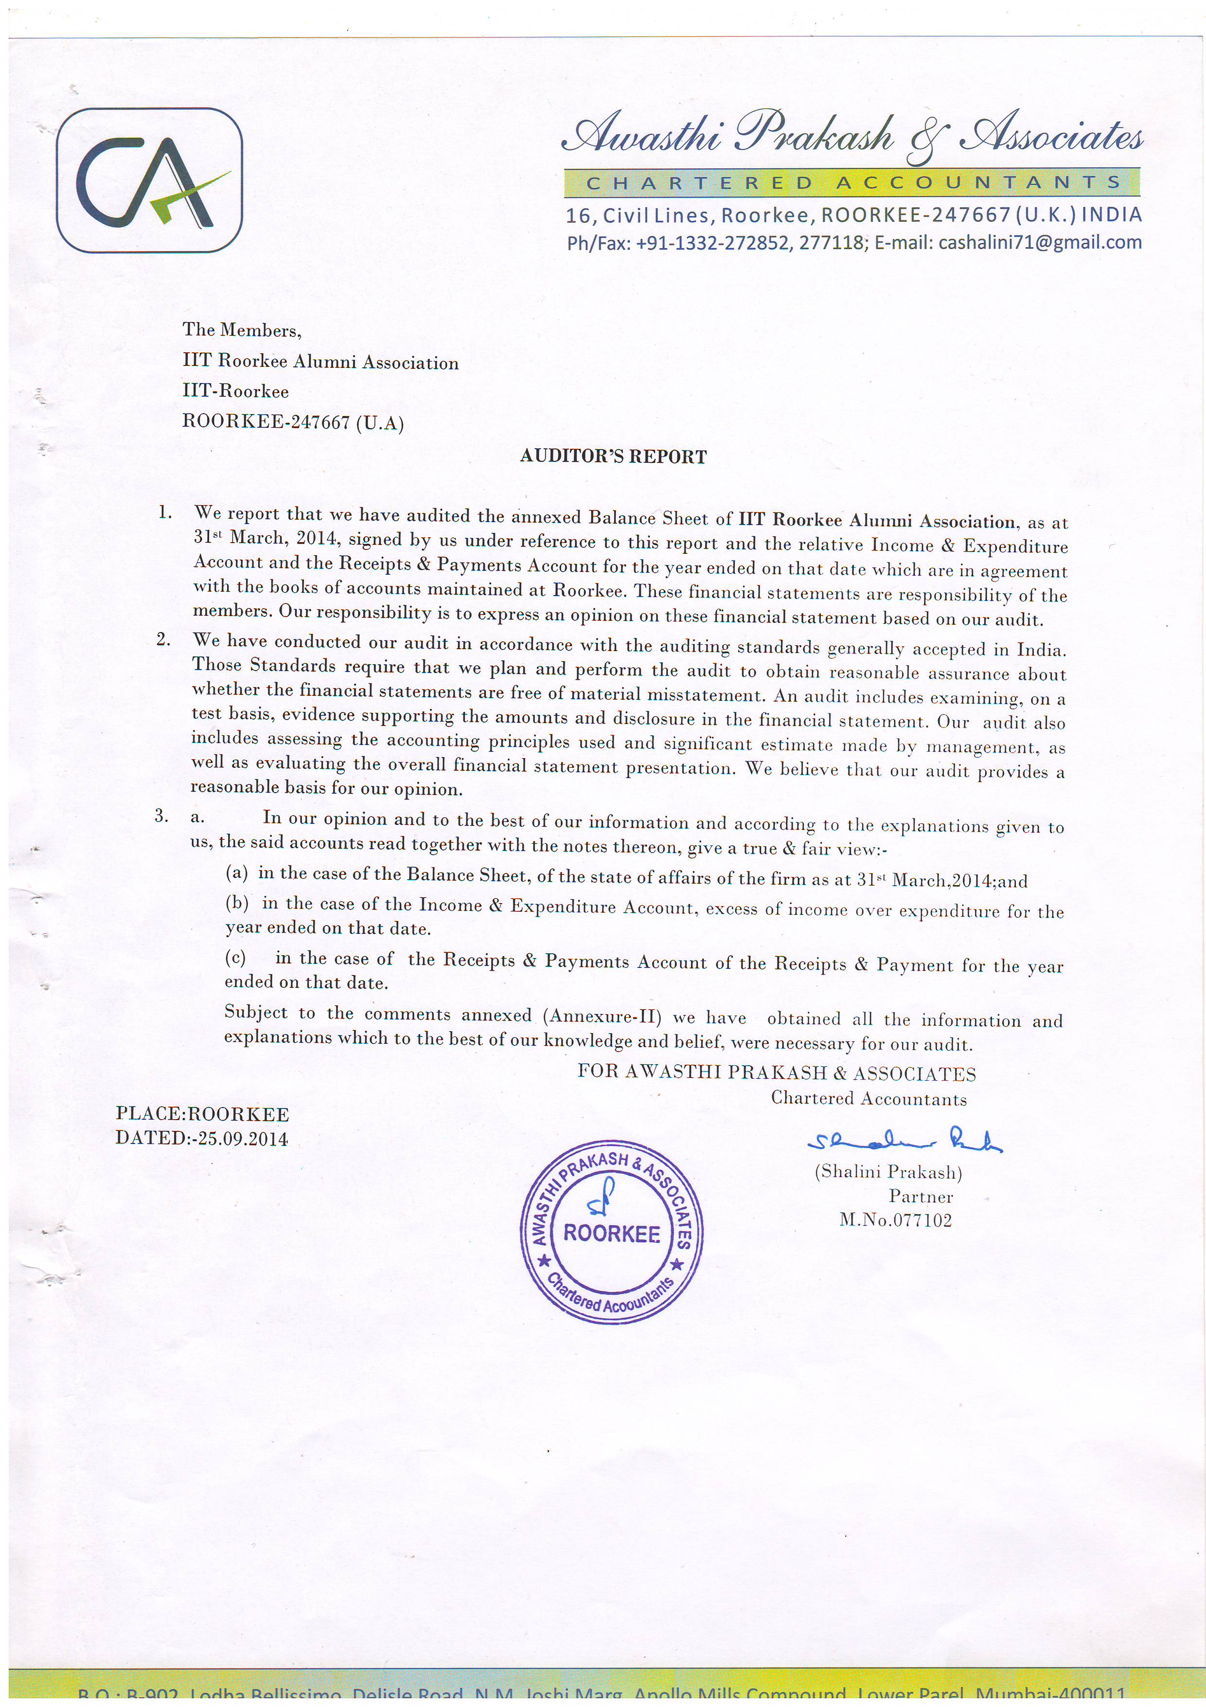
  - To consider the Audited Accounts for the period from April 1, 2013 to March 31, 2014
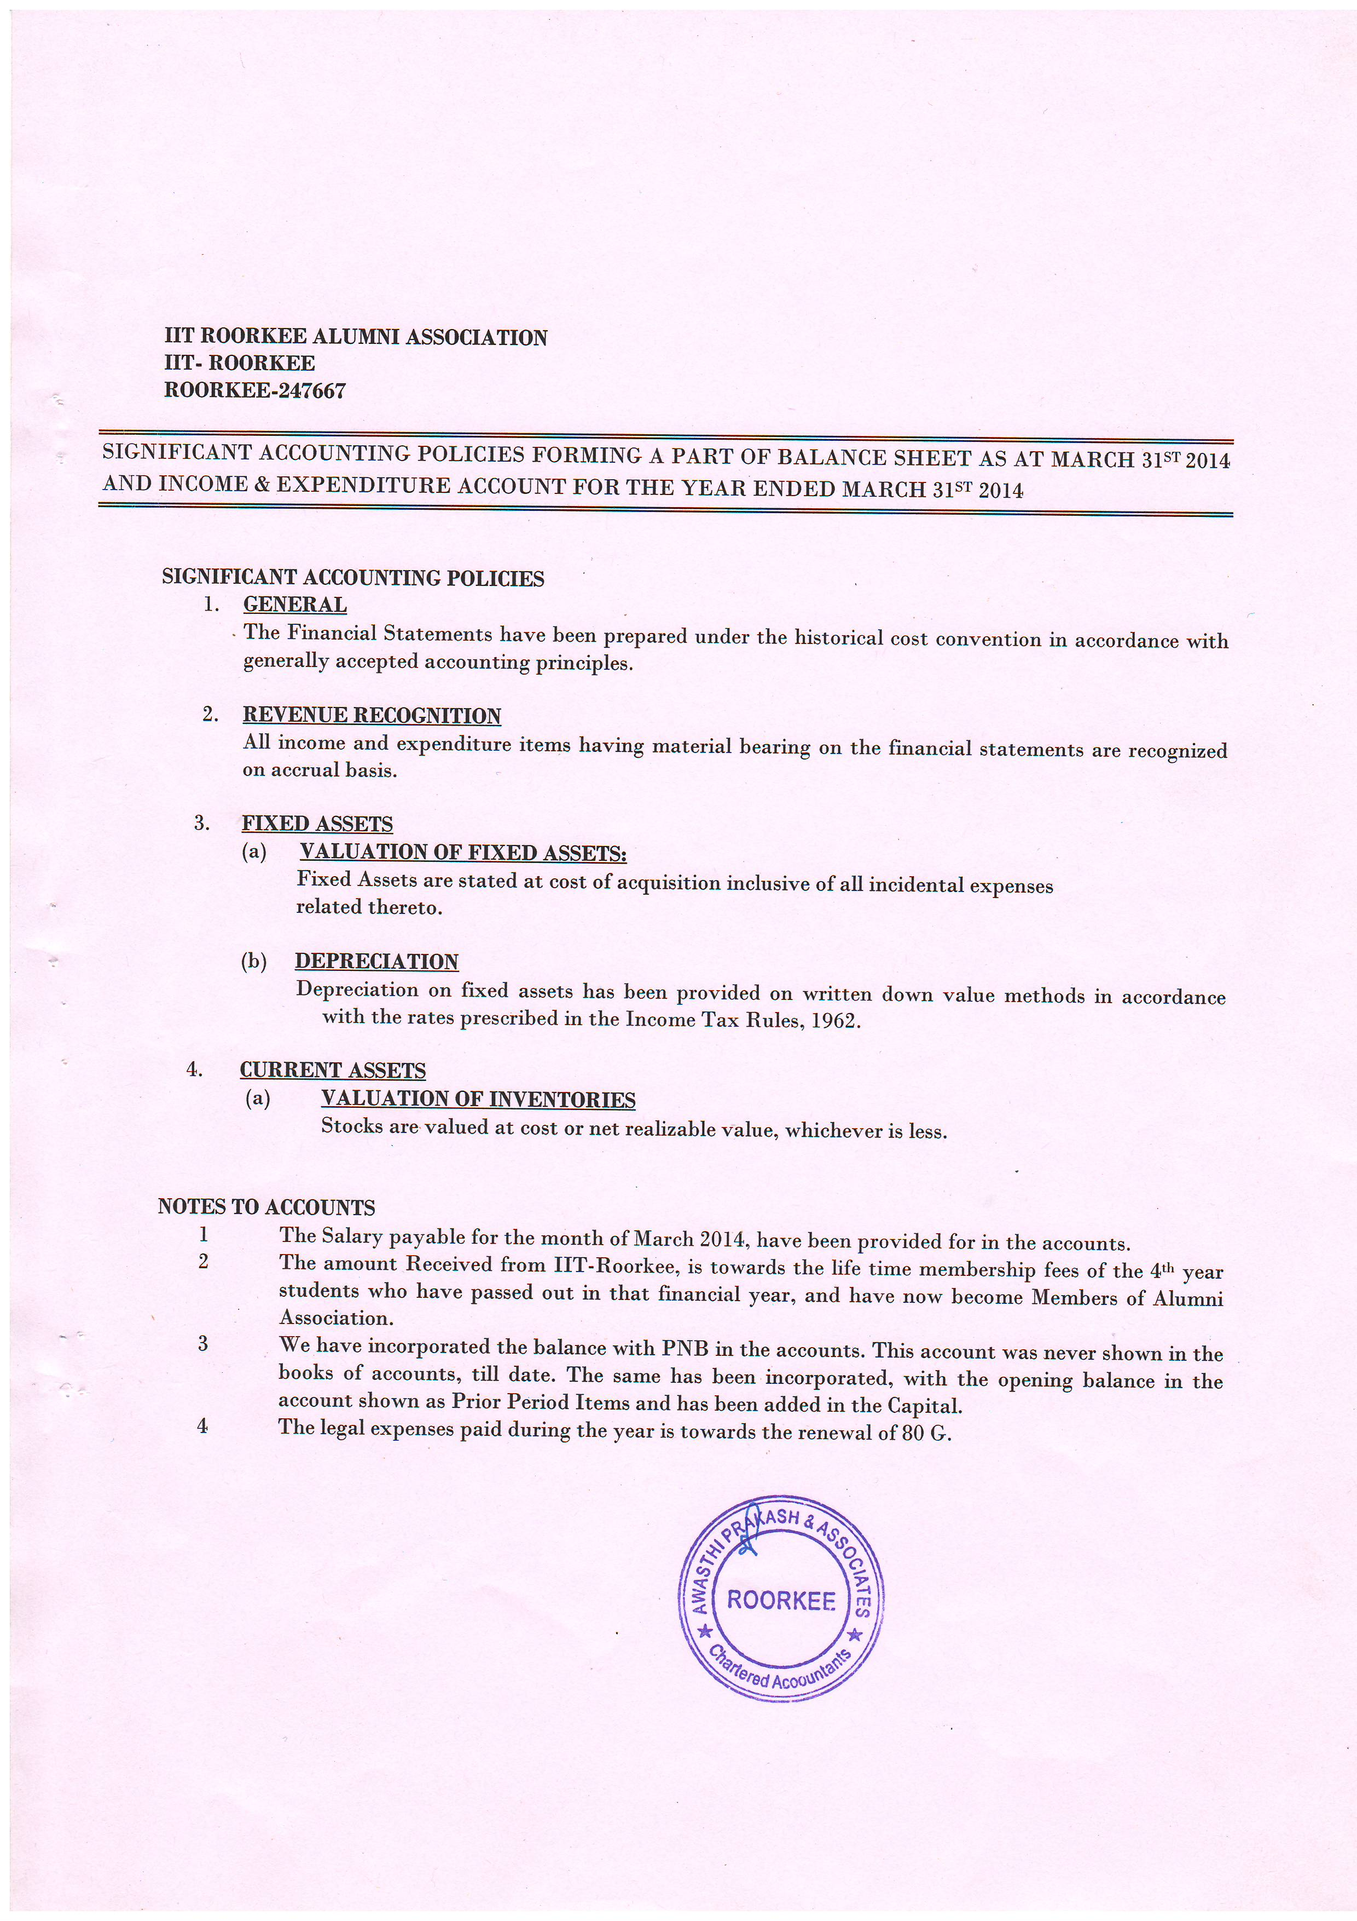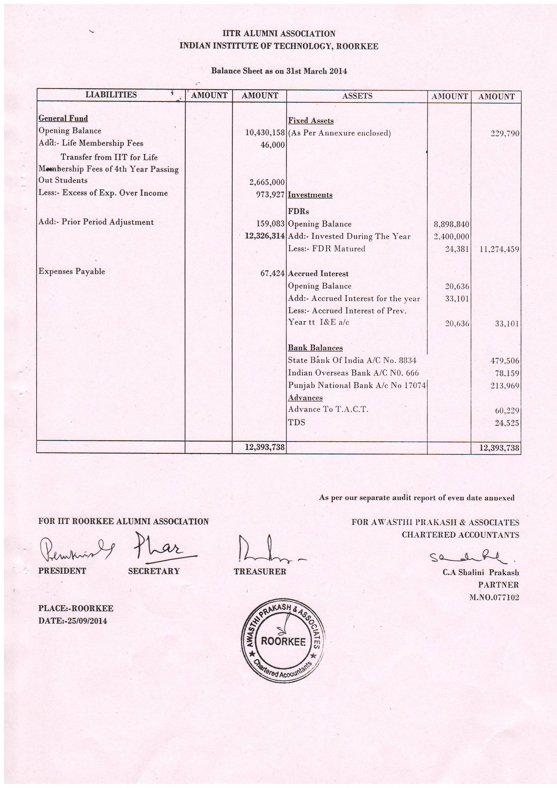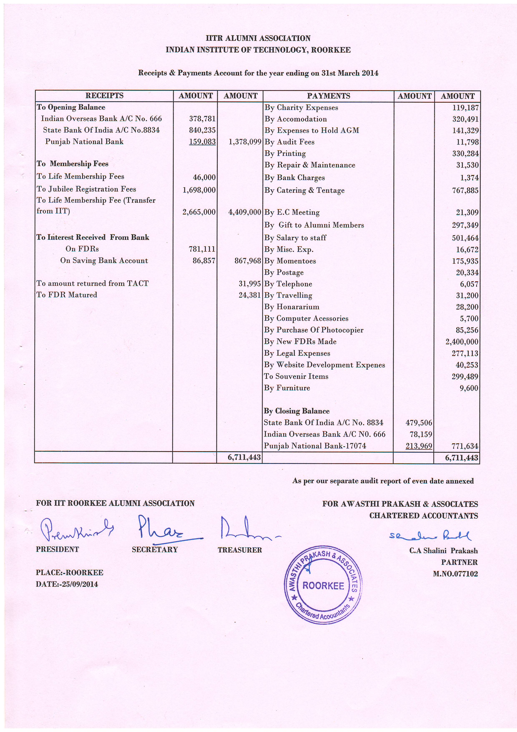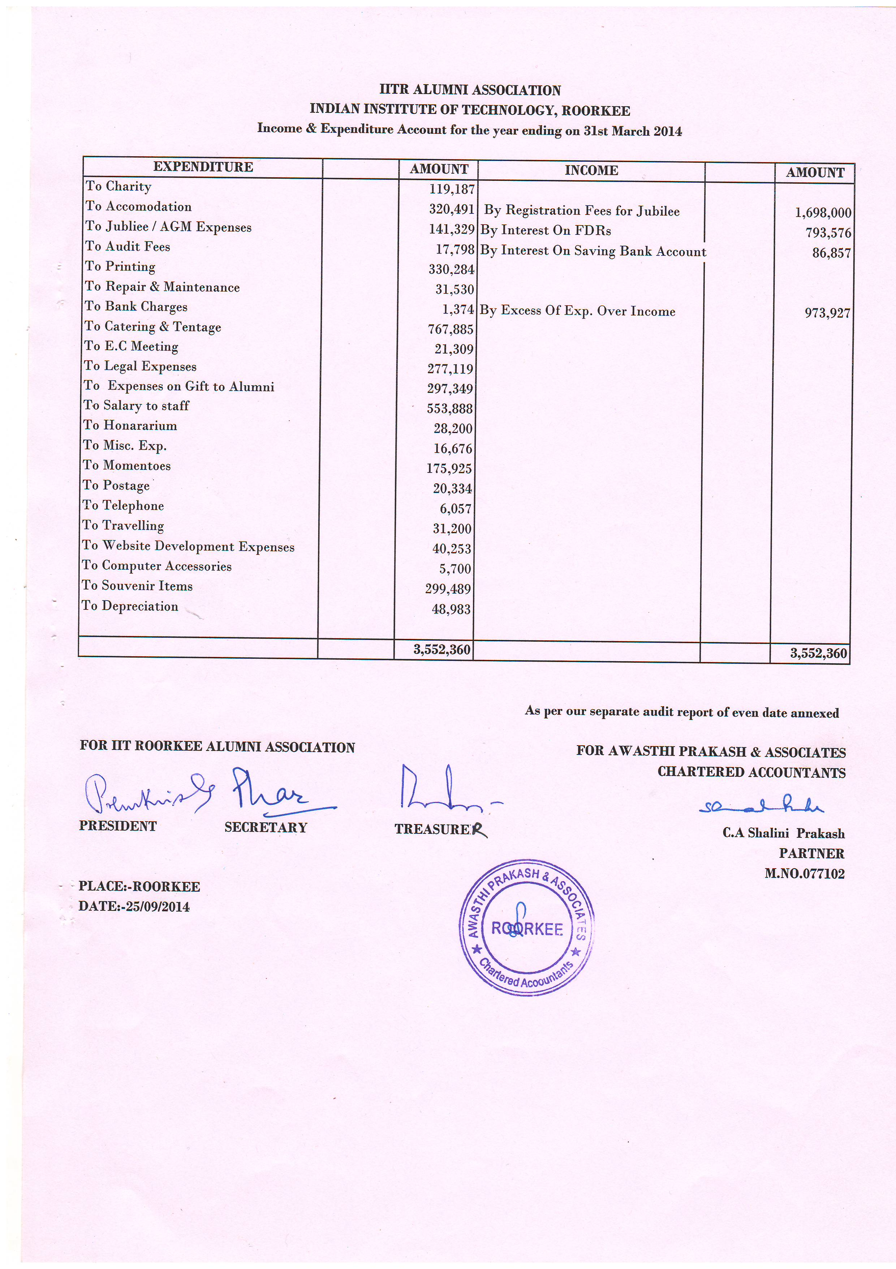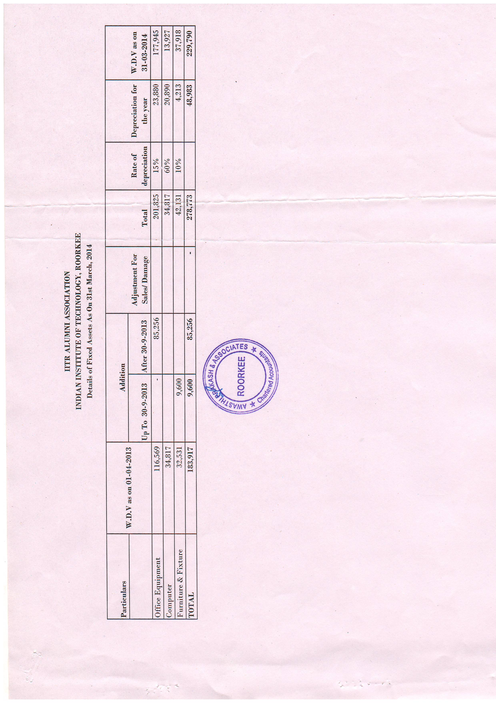
65.6 To consider the appointment of the Auditor for the financial year 2014-2015.

The EC has proposed that chartered Accountant appointed for the financial year 2013-14 may be continued for the financial year 2014-15 also. Submitted for the approval of members of AGBM.

  - To consider the Budget for the year 2015 – 2016

I request you to kindly see your report for its printed version. If anyone has some suggestion, please intimate us.

Budget Estimate for the Year 2015-16
Income |  | Expenditure
Membership fee | 2500000 | Printing & Stationery | 600000
Interest | 1000000 | Postage | 30000
Registration fee | 3000000 | Mementos & souvenir | 1000000
 |  | Transport/Travelling | 70000
 |  | Salary of staff /Honorarium | 750000
 |  | Hospitality | 950000
 |  | Boarding & Lodging | 1050000
 |  | Audit & Contingencies | 35000
 |  | Telephone & FAX | 15000
 |  | AGM | 200000
 |  | Activities with Local Chapters | 50000
 |  | PAN IIT | 50000
 |  | Photo identity cards for members | 100000
 |  | Webpage including office Assistant wages | 150000
 |  | Computer peripherals | 50000
 |  | Computer Accessories | 50000
 |  | Charity/Contributions to National Activities/students | 250000
 |  | Consumables / Contingencies Miscellaneous | 700000
 |  | Savings | 400000
Total | 6500000 |  | 6500000

65.8 Address by Prof. Pradipta Banerji, Director, IIT Roorkee, Roorkee.

Prof. Prem Krishna, President, Distinguished Guests, Fellow Alumni, Ladies and Gentlemen:

I extend a very warm and cordial welcome to you all who are present over here this afternoon and especially to our jubilee alumni, on behalf of IIT Roorkee (erstwhile University of Roorkee) and also on my own for revisiting your alma mater.

I am sure that this institution would have played a vital role in shaping-up your professional as well as your personal lives and you must be having pleasant memories of your stay in this lovely and beautiful campus. After leaving the portals of this institution you must have moved to different places to pursue your careers and reunions like these help to reconnect and re-strengthen friendships developed during your stay over here and also to network once again with your friends with whom you might have lost touch after leaving the portal of this institution.

In this 65th general body meeting of Alumni Association I welcome our Diamond, Golden, Ruby, Coral and Silver Jubilee Alumni who have completed their 60, 50, 40, 35 and 25 years of receiving degrees from this institution.

In its long and distinguished history, IIT Roorkee has a distinction of getting rechristened five times. Starting as Roorkee College in the year 1847, it was named Thomason College of Civil Engineering in 1854, Thomason College of Engineering in 1947, University of Roorkee in 1949 and IIT Roorkee in 2001.

We had also been given the responsibility of mentoring a newly created IIT Mandi in the state of Himachal Pradesh. First batch of students admitted to IIT Mandi has received education at IIT Roorkee Campus itself.

As most of you would be aware, all IITs have increased their intake of students at all levels. As on today, there are 7114 students on roll of IIT Roorkee consisting of 3930 B. Tech / B. Arch / IDD / Intergrated M.Tech., 2150 Post Graduate and 1034 Ph.D. Students. This figure is likely to increase to around 8800 in next few years.

The challenges of educating and housing this increased intake is an enormous task. You might have noticed a large number of new buildings under a massive construction drive that is taking place in the campus. With land being a scarce resource, we have no option but to grow vertically.

In addition to a 365 acre campus at Roorkee and 25 acre campus at Saharanpur, construction of 10 acre extension campus of IIT Roorkee in Greater Noida is also complete. A large number of parallel initiatives are also being undertaken to remove obsolescence in infrastructure and laboratories to keep pace with the changing technologies, so that our products can meet the challenges of real world. The campuses at Roorkee as well as at Saharanpur including all the rooms in bhawans (hostels) have Internet connectivity.

I am sure, during your stay, you will have the opportunity to go round the campus and see some of the new facilities that have been created like the new library, upgraded sports facilities in addition to your own departments.

I hope that you will have a pleasant stay in the campus and will continue to support your alma mater in whatever way you can in future also.

I wish you all the best in your professional and person lives.

Thank You,

  - To consider the by-laws of IIT Roorkee Alumni Association pertaining to local chapters.

Bye Laws Pertaining to Local Chapters

Existing | Proposed
(7) Local Chapters  - The relationship of the parent Association with the Local Chapters will be governed by bye-laws of the Association.  - The Executive committee may recognize a Local Chapter of the Association in any city provided it has 20 members enrolled. A centre with less than 20 members but more than five members will be recognized as a Sub-Chapter and it will be attached to the Local Chapter.  - The Local Chapters shall not be normally, under the financial control of the Parent Association at Roorkee. However, if any Local Chapter organizes an activity using the name and patronage of the parent body, they will transfer 20% savings from the activity to corpus fund of the parent body at IIT Roorkee.  - The Local Chapters should normally hold activities pertaining to their jurisdiction only. The jurisdiction of Local Chapters will be defined by the parent body from time to time.  - Local Chapters will take prior approval of the parent body before organizing events of regional/national/global nature involving members beyond their jurisdiction.  - In case annual revenue of a chapter exceeds one lakh, the accounts must be audited and certified copies of the balance sheet and audit report submitted to the parent body at Roorkee. | (7) Local Chapters  - As alumni of IITR are spread all over India and abroad, it is desired that they get connected through the Local Chapters & exchange their professional / cultural experiences for their own benefit and the society at large.  - These centres will function independently and in no way will be connected to IITRAA financially.  - In any city / region, a collection of 25 or more alumni can, and are encouraged to form a Local Chapter. Normally there will be one chapter per city in India and one per country abroad.  - This is besides any informal group activities, wherever alumni groups may so wish. In, such cases, a coordinator may be chosen, in order to facilitate connectivity.  - Each Local Chapter will be served by an Executive Committee (EC) with a Chairman, a Secretary, a Treasurer and a minimum of 3 Executive Members. Tenure of an EC shall be of 2 years. The names along with their contact details will be communicated to IITRAA.  - Local Chapter shall organise at least 1 activity in a year.

  - Announcement of President and Honorary Secretary nominated for the next year

  - Election of the Executive Committee members for the 2015-16

  - Declaration of ROBA Quiz Prize winner

  - Any other item with the permission of the Chair

IITR ALUMNI ASSOCIATION

PRESIDENTS AND SECRETARIES
Year | President | Secretary
2014 | Prem Krishna | Pradeep Kumar
2013 | J. L. Gaindhar | Pradeep Kumar
2012 | J. L. Gaindhar | N. K. Samadhiya
2011 | P.K. Pande | N. K. Samadhiya
2009-10 | D. V. Singh | Ashok K. Ahuja
2007-08 | R. K. Singh | Manoj K. Arora
2004-06 | V. K. Agnihotri | R. P. Maheshwari
2002-03 | Pradip Baijal | S. K. Ghosh
1998-2001 | H.S. Agarwal | A. K. Mathur
1997 | D.V. Singh | V. K. Goel
1996 | D.V. Singh | Surendra Kumar
1995 | Ashok Bhatnagar | Surendra Kumar
1994 | S.K. Khanna | S. C. Handa
1993 | R.P. Singhal | S. C. Handa
1992 | Rajendra Prakash | S. C. Handa
1991 | Harish Chandra | V. P. Bansal
1990 | Raj Kumar Jain | Ashok K. Jain
1989 | Bhupal Singh | Ashok K. Jain
1988 | G.C. Agarwal | Ashok K. Jain
1987 | G.C. Agarwal | S. K. Mittal
1986 | R.C. Mangal | S. K. Mittal
1985 | Vijendra Singh | S. K. Mittal
1984 | K.M.Maheshwari | V. K. Tiwari
1983 | O.P. Jain | V. K. Tiwari
1982 | D.R. Singh | A. K. Gupta
1980-81 | Dinesh Mohan | A. K. Gupta
1979 | Hari Krishna | A. K. Agarwal
1978 | V.R. Vaish | A. K. Agarwal
1977 | K..C. Goyal | V. Charan
1976 | J.S. Dhillon | Satish Chandra
1975 | N.D. Gulhati | Shamsher Prakash
1974 | Jivan Datt | Shamsher Prakash
1973 | S.K. Jain | R. N. Agrawal
1972 | H.G. Verma | R. N. Agrawal
1971 | Jai Krishna | A. S. Arya
1970 | S. C. Katoch | A. S. Arya
1969 | J. P. Mital | M. K. Singhal
1968 | Baleshwar Nath | Satish Chandra
1967 | D. B. Anand | Satish Chandra
1966 | D. S. Nag | Satish Chandra
1965 | D. C. Baijal | Rajendra Prakash
1964 | H. P. Sinha | Rajendra Prakash
1963 | Yadav Mohan | Rajendra Prakash
1962 | G.K. Agarwal | K. V. Mital
1961 | Kanwar Sain | K. V. Mital
1960 | P.L. Verma | Dinesh Mohan
1959 | Karnail Singh | Dinesh Mohan
1958 | Ghananand Pandey | Dinesh Mohan
1957 | H.K.L. Sethi | S. N. Gupta
1956 | K.N. Kathpalia | S. N. Gupta
1955 | M.S. Bisht | S. N. Gupta
1954 | M.S. Mathur | S. N. Gupta
1953 | Balbir Singh | S. N. Gupta
1952 | A.N. Khosla | S. N. Gupta
1951 | L.P. Misra | S. N. Gupta
1950 | C.A. Hart | Jai Krishna
1949 | N.N. Chakravarti | Jai Krishna
1947-48 | B.D. Puri | Jai Krishna
1946 | G. Lacey | Jai Krishna
1940-45 | M.G. Sardana | Jai Krishna

